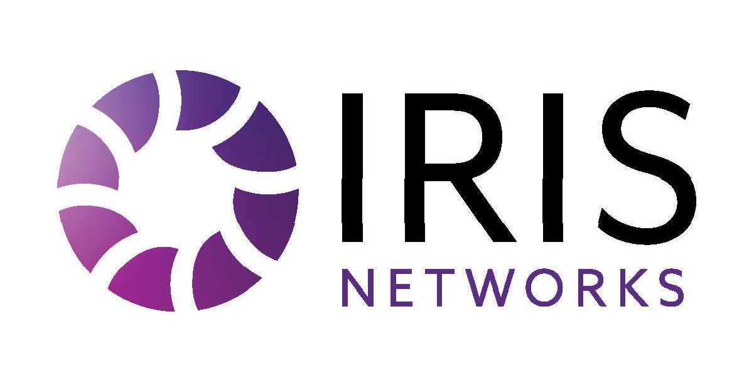

Each year, IRIS Networks is required by Federal Communications Commission (FCC) regulations to obtain Federal Universal Service Fund (“FUSF”) contributor certification from its customers to determine their FUSF status. This certification is required pursuant to 47 CFR §§ 54.706, 54.708, and 54.711. Please complete and return the attached 2026 FUSF Certification form for each FCC 499 Filer ID under which you purchase services from IRIS Networks, even if you have submitted a similar form to IRIS Networks in prior years.
For self-contributing customers, IRIS Networks will not apply 2026 FUSF surcharges to any account for which a completed and signed Certification Form is received; provided that your contributor status can be verified through the FCC’s 499 Filer Database: https://apps.fcc.gov/cgb/form499 .
If you do not contribute directly to the FUSF or have not filed a Form 499-A with the FCC, please provide an explanation as to why such a filing is not required (see page 2 of the attached form). If you purchase Private Line services that are jurisdictionally intrastate as defined by FCC guidelines, you may instead complete the Private Line Jurisdiction Certification Form, which is included with this correspondence.
Please submit the completed Contributor Certification form, along with any required attachments, to the following email address.
- Email: fusf@irisnetworksusa.com

If IRIS Networks does not receive a valid 2026 FUSF Contributor Certification form, by February 27th, 2026, the FUSF surcharge will be assessed on telecommunications services and interconnected VoIP services purchased by your Company as of January 1, 2026, and will appear on the March 2026 invoice. Failure to submit a valid form will result in FUSF surcharges being billed by IRIS Networks, even if you also contribute directly to the USF mechanism based on your end-user revenue from resale services. Iris Networks will retain all FUSF certifications and support documentation for a minimum of five years, as required by FCC regulations.
If you have submitted your 2026 FUSF Certification Form within the last 90 days, no further action is required.

· If you have any questions, please contact our accounting department at fusf@irisnetworksusa.com.

Thank you!

Company Name (“Company”):¹

(Full Legal Name)

Form 499 Filer ID:

Authorized Representative’s Name & Title:

Authorized Representative’s Address:

Authorized Representative’s Telephone Number:

Authorized Representative’s E-mail:
Effective January 01, 2026 until it is revoked or withdrawn by Company.
Note: Unless you notify IRIS Networks that an account should be excluded from the scope of this certification, this certification will apply to all the IRIS Networks accounts under the company name provided above. You must provide IRIS Networks with a list of all your company’s IRIS Networks’ wholesale accounts that are not covered by this certification. Such accounts will be subject to Federal Universal Service Fund surcharges.

I am authorized to sign this Certification on behalf of the company named above.

I understand that IRIS Networks is relying on the representations contained in this Certification and that IRIS NETWORKS, therefore, will not contribute to the FUSF on the revenue generated from services sold to Company.

I understand that if Company fails to provide a timely and complete Certification, IRIS Networks will classify the revenues it generates from services sold to Company as end-user revenue and IRIS Networks will contribute to the Federal Universal Service Fund (“FUSF”) on that revenue, as appropriate. I also understand that in such instance, IRIS Networks will assess Company a surcharge to recover the amount of its FUSF contribution, which Company will be obligated to pay.

Further, I understand that IRIS Networks may bill Company for any FUSF surcharges waived because of this certification, if the representations contained in this Certification are inaccurate and IRIS Networks reclassifies Company as an end user with respect to interstate telecommunications services, interconnected VoIP services, or any other telecommunication services sold to Company. In such instance, Company will be obligated to pay such surcharges.

I understand that if any of the information or representations made in this Certification change, Company must notify IRIS Networks of any such change(s) within 30 days of the change and, if required by IRIS Networks, Company will submit a new Certification.

I understand that IRIS Networks will require Company to provide a new Certification on an annual basis.

I agree that IRIS Networks may provide a copy of this Certification to the Universal Service Administrative Company, the FCC, or other party as required by law.

Company Name (“Company”):
(Full Legal Name)

Certification:
Please place an “X” beside all statements that apply:
- I certify under penalty of perjury that my company is purchasing service for resale in the form of telecommunications or interconnected Voice over Internet Protocol service. I also certify under penalty of perjury that either:
Company contributes directly to the federal universal support mechanisms, or
that each entity to which I provide resold telecommunications is itself an FCC Form 499 worksheet filer and a direct contributor to the federal universal service support mechanisms.
that Company is a non US telecommunications carrier and uses the IRIS Networks Services only to provide non-US telecommunications services or non-US VoIP services (i.e., services that either originate or terminate in the US for which all revenues are from (i) non-US end users, or (ii) US resellers that they themselves are currently direct FUSF contributors via monthly payments to USAC).
I certify under penalty of perjury that Company is a de minimis telecommunications carrier and or telecommunications provider as defined in Section 54.708 of the Federal Communications Commission universal service rules and authorize IRIS Networks to invoice Company for any Federal Universal Fund contributions it remits on Company’s behalf.

I do not directly contribute to the federal universal support mechanisms and authorize IRIS Networks to invoice Company for any Federal Universal Fund contributions it remits on Company’s behalf.

The undersigned individual is authorized to make this certification on behalf of the above-named Company and every company covered under the Form 499 Filer ID (if applicable).

By:
(Signature)

(Print name)

Title:

Date:

Please submit the completed form by email to fusf@irisnetworksusa.com.

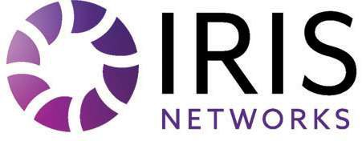

Effective Date: 1/1/2026
Dear Customer:

PRIVATE LINE JURISDICTION CERTIFICATION FORM
Company Name (“Company”):
Account #:

The Federal Communications Commission (“FCC”) has established certain rules and requirements relating to the jurisdictional classification (interstate vs. intrastate) of telecommunication services provided by companies such as Tennessee Independent Telecommunications Group LLC (hereinafter “IRIS Networks”).
Upon routine review of telecommunications carriers, the Federal Communications Commission (“FCC”) Form 499-A requests that intrastate classification be obtained from customers certifying whether or not the total interstate traffic exceeds 10% for the intrastate transport point-to-point services provided. If so, such services will be subject to Universal Service Fund (“USF”) fees. These are circuits that connect one physical location to another.
Federal USF fees are applied to all interstate telecommunication services. USF fees also apply to point-to-point circuits with interstate usage greater than 10% regardless if the end points are within the same state boundaries (intrastate). If the interstate usage is 10% or less and the end points of the circuit are within the same state boundaries then USF fees will not apply. There is no exemption based on not-for-profit or government entities.
Company acknowledges that IRIS Networks’ determination of jurisdiction of the Service(s) and assessment of USF fees will be based upon the information provided by Company in this Certification. If IRIS Networks determines that the jurisdiction has been established based upon false, inaccurate or erroneous information, IRIS Networks may bill Company and Company will pay such fees based upon the determination of jurisdiction, plus applicable late fees. Company acknowledges and agrees that: (i) it has a duty to update this Certification within thirty (30) days to the extent its usage changes and this Certification is no longer accurate; and (ii) IRIS Networks may provide a copy of this Certification to the Universal Service Administrator, the FCC, statue regulatory agencies and taxing authorities, legal counsel, or an auditor.

Certification of Jurisdiction: A signed Certification Form must accompany a signed Service Agreement for the Service(s) whether Company is able to certify at this time or not.*
Company acknowledges and certifies that the total interstate traffic (including internet and usage-based traffic) for the Service(s) listed below constitutes the jurisdictional classification as indicated. Indicate: (i) (YES) if the interstate traffic is greater than 10% and therefore subject to USF fee; (ii) (NO) if the interstate traffic is 10% or less and therefore not subject to USF fee; or (iii) (DEFER*) if Customer is not able to certify the jurisdiction classification of the Service(s) at this time. In the event Customer defers jurisdictional classification, Customer will be required to send the completed Certification Form to Customer Support at fusf@irisnetworksusa.com or contact IRIS Networks at 615-425-2318 within thirty (30) calendar days from the execution of the Service Agreement or USF fee(s) will be assessed until such time as the Certification Form to the contrary is received.

Circuit ID # | Service | Address Information |  | USF  Certification (Yes/No/Defer)
Circuit ID # | Service | A Location | Z Location | USF  Certification (Yes/No/Defer)
- Check here if information is continued on subsequent page(s).

By:
(Company Name)
Authorized Signature:
Name: | Email:
Title: | Phone:
Date:

Confidential & Proprietary

